**Kontroller:** App design

**Version**: 2.0  
**Date**: July 2025

**Table of Contents**

1. Menu interface to sign in or sign up 2

2. Sign in and sign up interface 3

3. Main (profile) interface 5

4. Interface of Games, Playlist and inside a List 7

5. Interface of Diary 8

6. Interface for Reviews 9

7. Interface of Likes (including reviews, comments and games) 10

8. Interface of Activity 11

9. Interface of Lists 12

10. Interface of a game 13

11. Interface of a game review 14

12. Interface of Friends and people 15

13. Interface of search engine 16

# 

# **Menu interface to sign in or sign up**

# 

**Description**

**Purpose:** This is the initial landing screen of the **Kontroller** web application.

**Design:**

At the center, there's a semi-transparent UI card with the following layout:

* **Main CTA header:** “Get started with your game playing journey” (styled in bold blue text).
* **App name:** “Kontroller” is displayed prominently underneath the header.
* **Action Buttons:**
  + **Sign In** (links to the login screen)
  + **Sign Up** (links to the registration screen

# **Sign in and sign up interface**

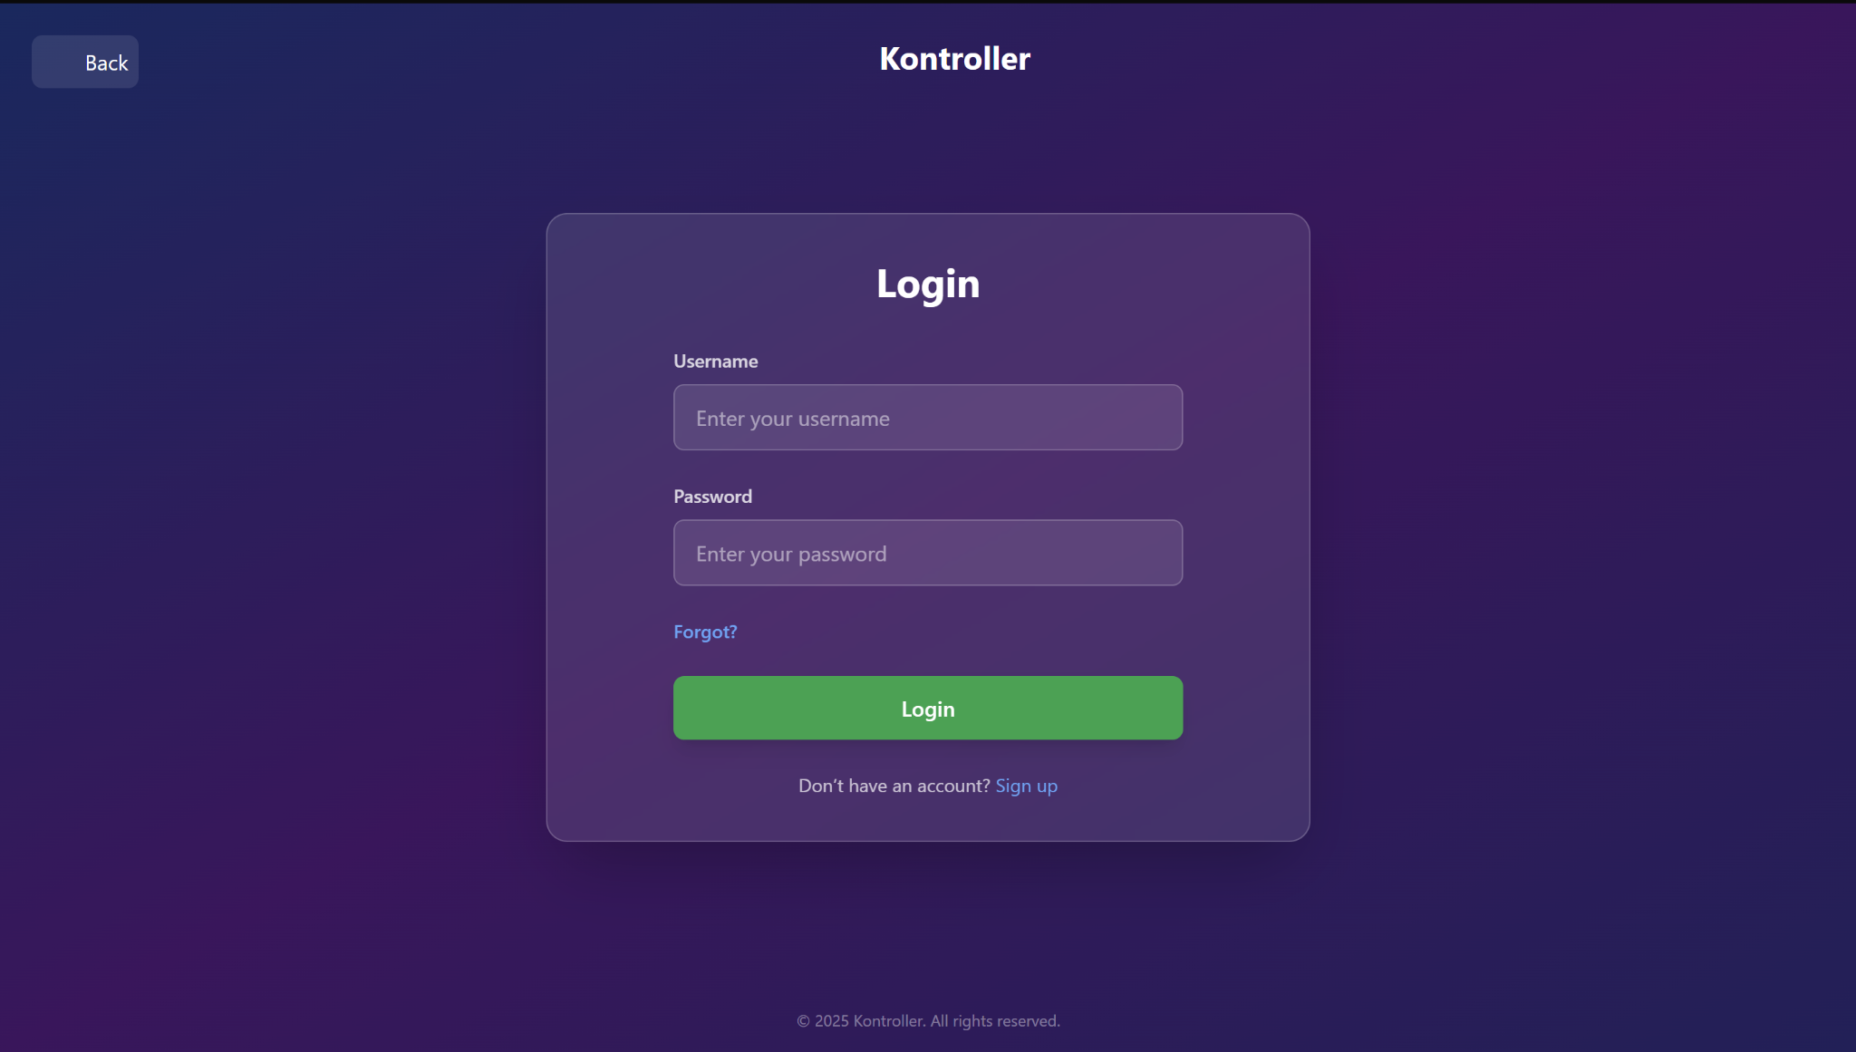

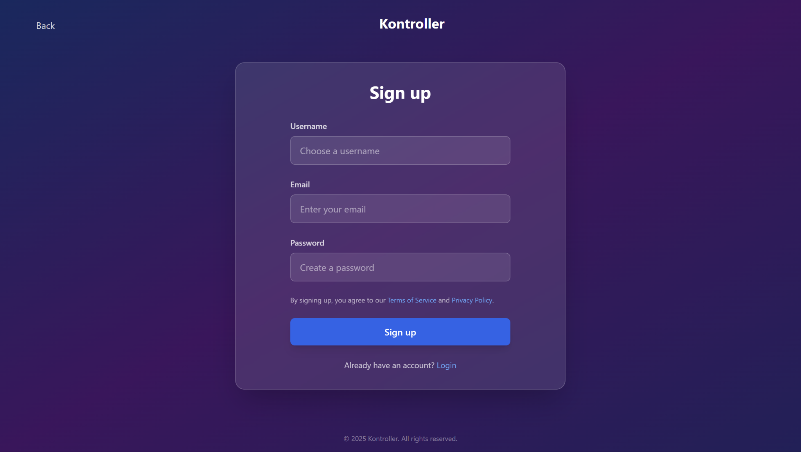

**Description**

**Purpose:** This screen provides a side-by-side layout for **Login** (left panel) and **Sign Up** (right panel).

**Design:**

**Login Section**

* **Header:** Large “Login” title
* **Fields:**
  + **Username**: Text input
  + **Password**: Password input
* **Buttons:**
  + **Forgot?**: Link-style button for password recovery
  + **Login**: Main login button, green on blue

**Sign Up Section**

* **Header:** “Sign up”
* **Fields:**
  + **Username**
  + **Password**
  + **Email**
* **Buttons:**
  + **Signup**: Main register button

# **Main (profile) interface**

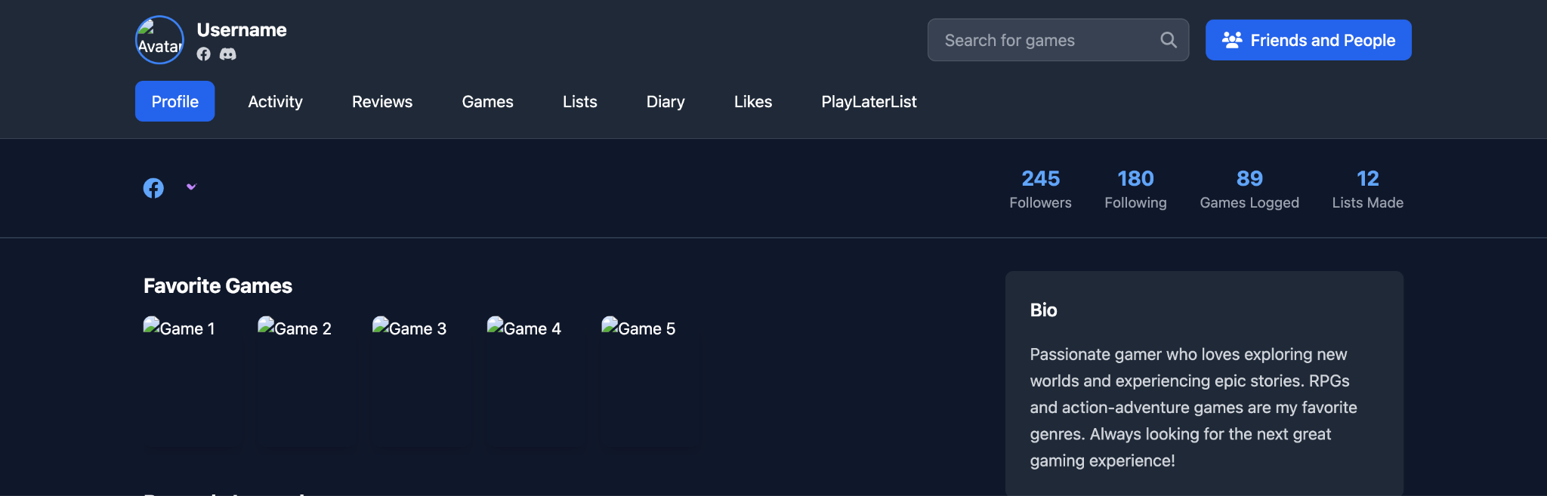

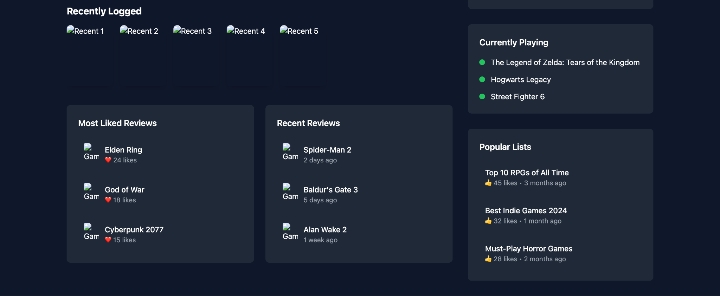

**Description**

**Purpose:** This is the screen for users to manage their profiles

**Design:**

**Profile Header**

* **Avatar**: A picture selected by the user
* **Username**
* **External Links**: Icons linking to external websites (e.g. Facebook, Discord). When clicked onto will transfer the user to the Facebook or Discord sites
* **Displaying stats**:
  + Number of Followers
  + Number of Following
  + Number of Games Logged (Rated)
  + Number of Lists Made

**Navigation bar**

* Navigation buttons:
  + Profile
  + Activity
  + Reviews
  + Games
  + Lists
  + PlayLaterList
  + Likes

**The main navigation bar along with the avatar and the username will be displayed on the top of every window of all the featured windows included in the navigation bar.**

**Activities**

* 5 Favorite Games (displayed with large posters)
* 5 Most Recently Logged Games (posters)
* **Bio:** allows users to write their bios
* **Games that users are in the process of playing:** displays 3 names, picked by users
* **Most Liked Reviews** (clickable): when clicked, transfer to the window of the reviews
* **Most Recent Reviews** (clickable): when clicked, transfer to the window of the reviews
* **Most Popular Lists** (clickable): when clicked, transfer to the window of the list

# **Interface of Games, Playlist and inside a List**

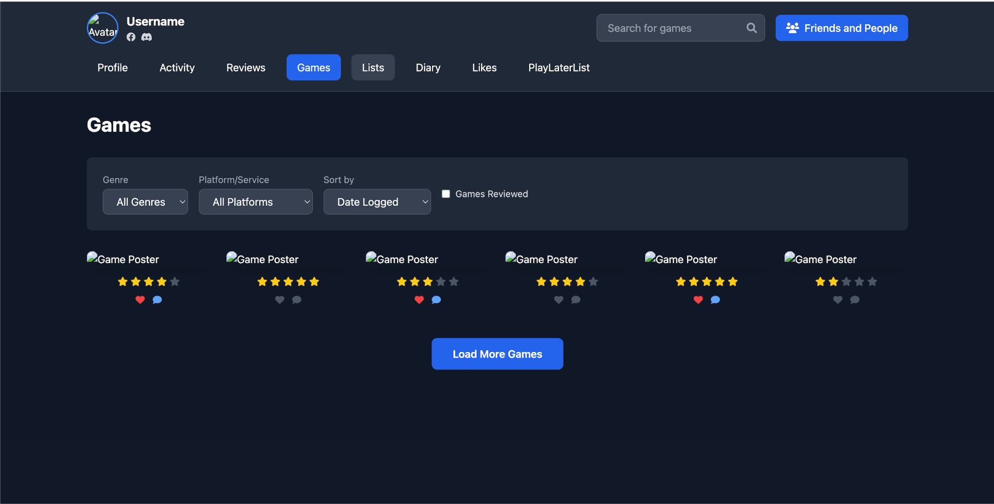

**Description**

**Purpose:** This is the screen used for displaying games users log, in their PlayLaterList or any list.

**Design:**

**Grid Layout**

* Games displayed as **posters** in a flexible grid.
* Each poster shows below them:
  + Star rating (1–5)
  + Heart icon if liked
  + Comment/review icon if review exists

**Filter Bar**

* Genre
* Platform/Service
* Sort by (this will include by date published, by rating (average and users’ rating))

**Note: Watchlist does not use the reviewed filter to sort out games that have reviews and also the ratings.**

# **Interface of Diary**

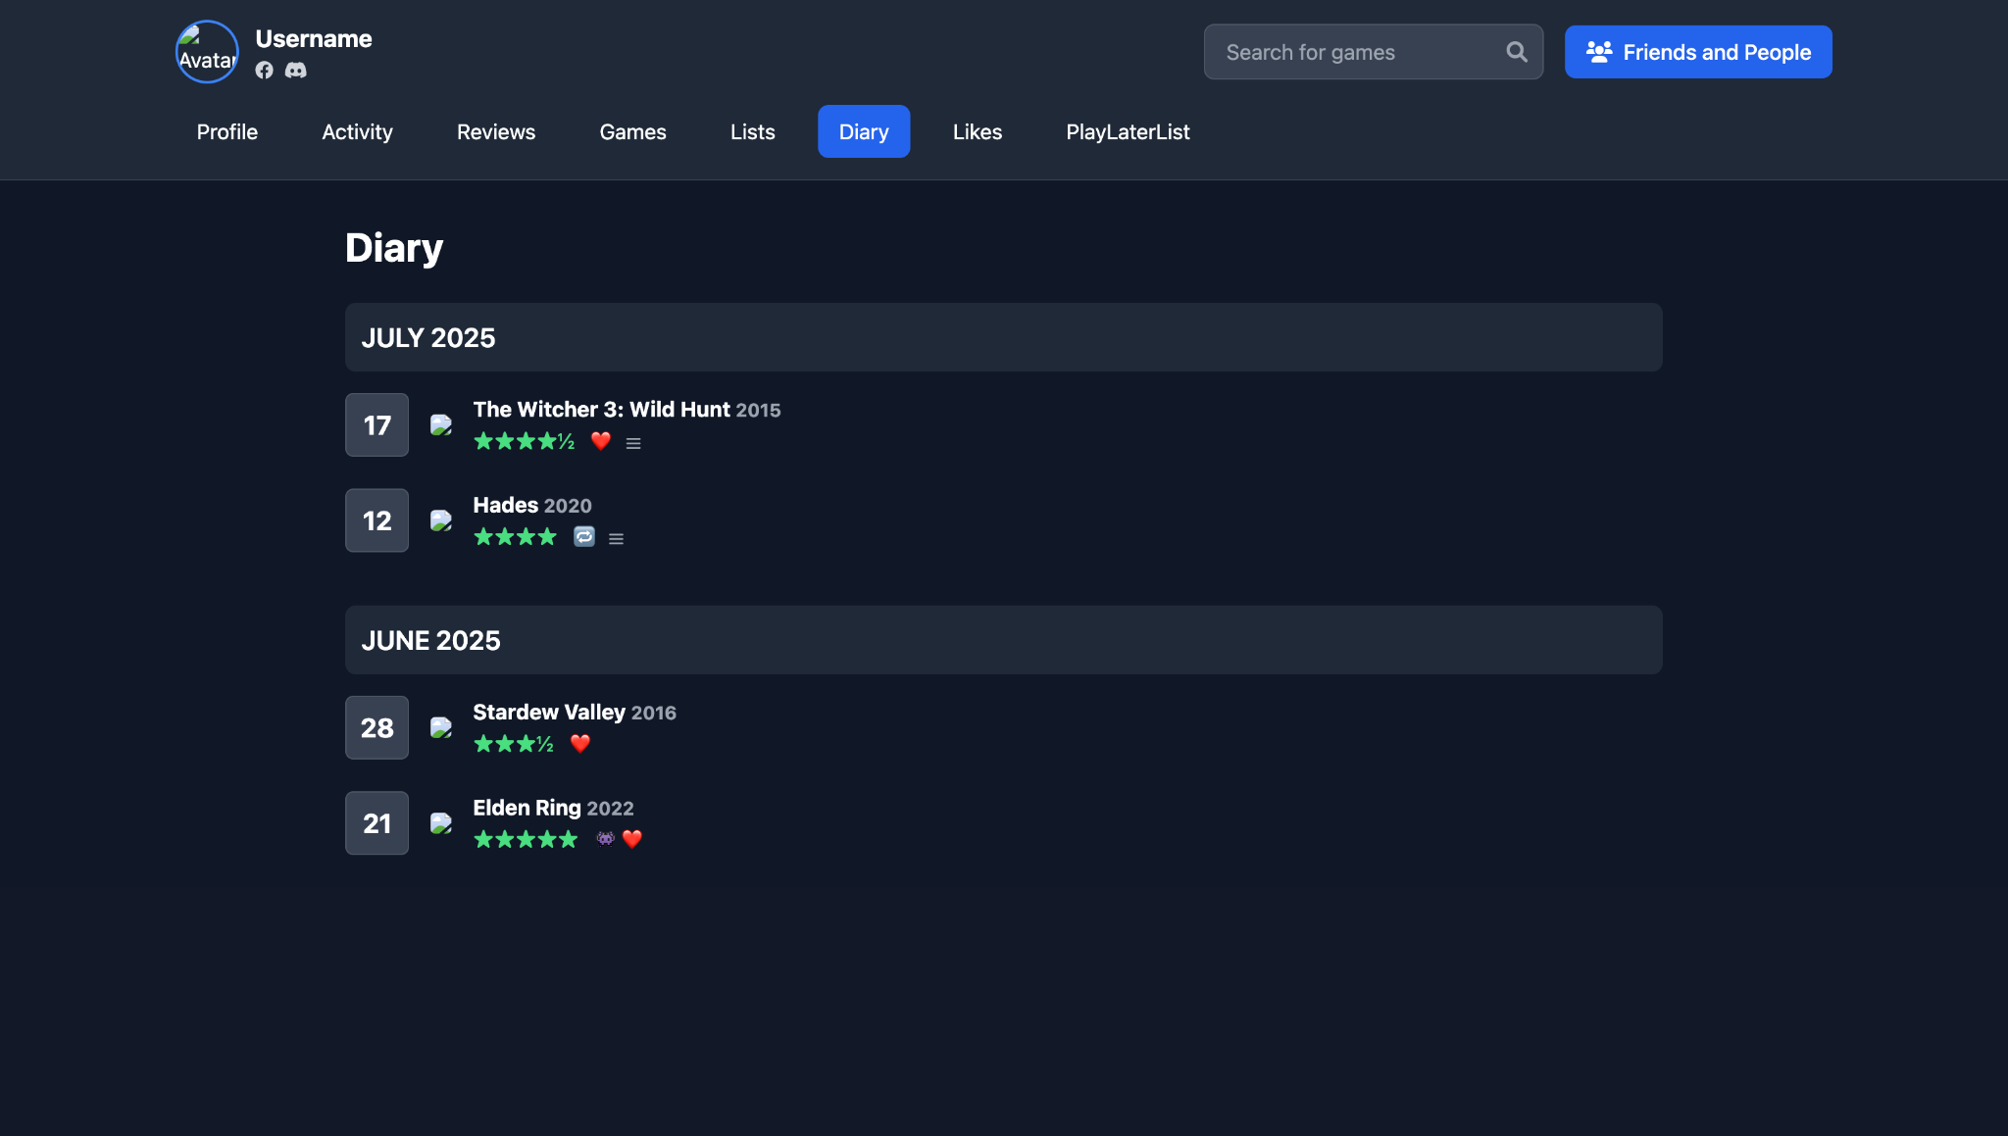

**Description**

**Purpose:** This is the screen to view users’ diaries  
**Design:**

**Monthly Timeline**

* Displayed by month (e.g., "June 2025").
* Calendar view: days of the month shown.
* Posters of games logged on each day (put right next to the day).
* Filter bar (like Games and watchlist)

# **Interface for Reviews**

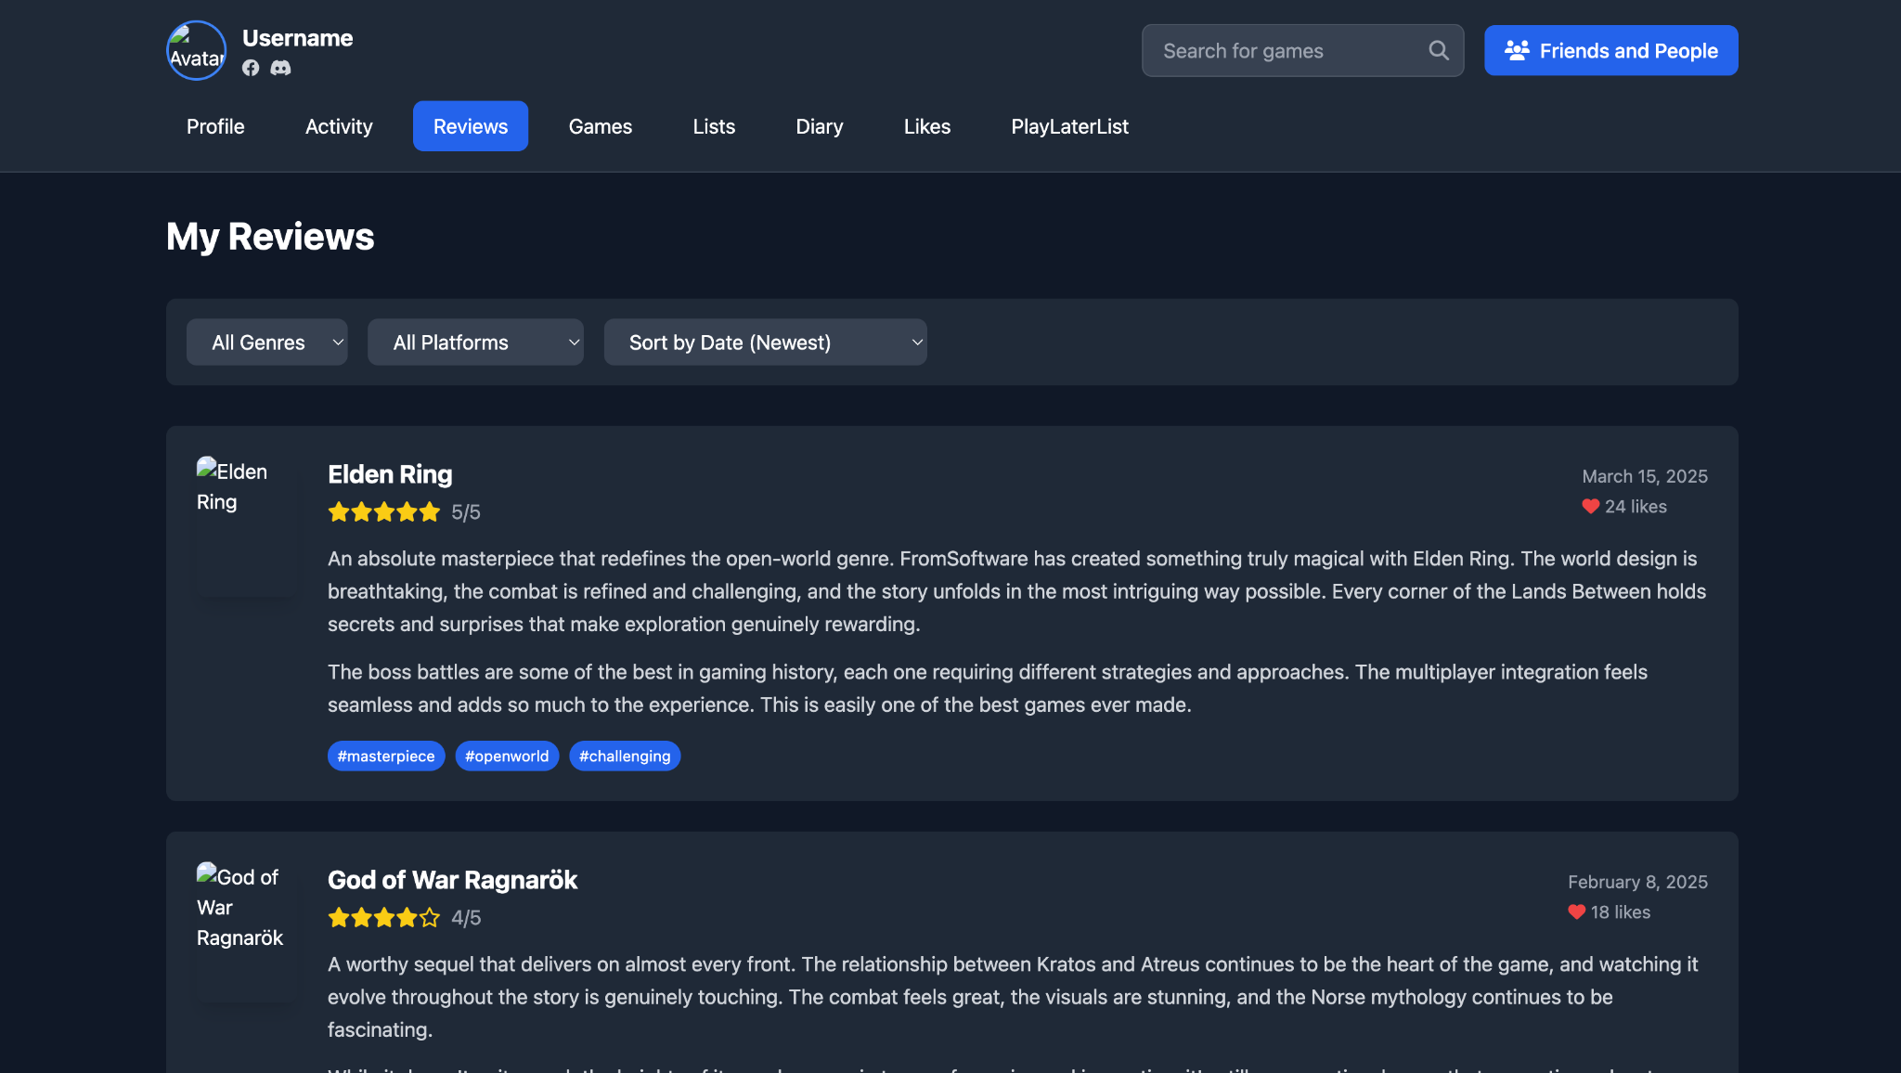

**Description**

**Purpose:** This screen is to display all of the users’ reviews.

**Design:**

* Game poster
* Game name
* User review (text)
* Date
* Filter bar (like Games and watchlist)

# **Interface of Likes (including reviews, comments and games)**

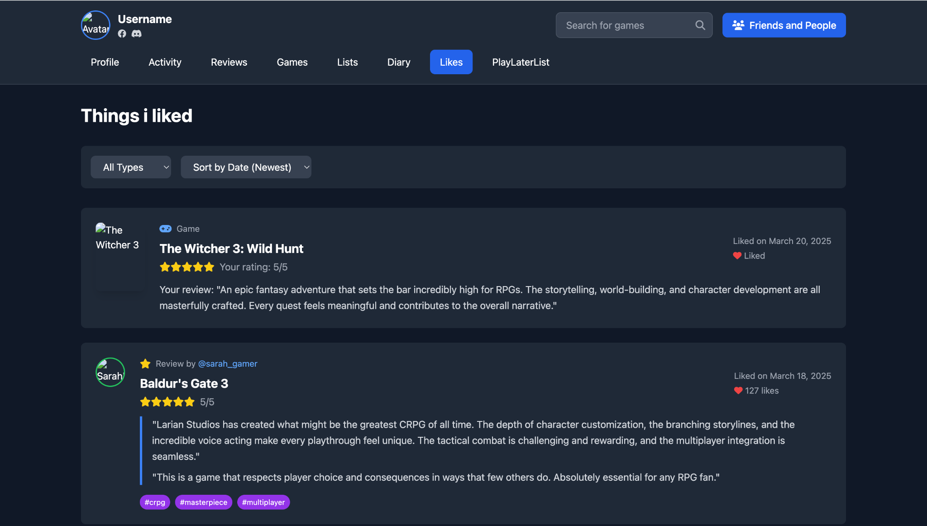

**Description**

**Purpose:** This screen is to display everything users like.

**Design:**

**What Users Have Liked**

* Includes:
  + **Reviews (made by other users)**
  + **Comments (made by other users)**
  + **Games**

**Display Format**

**1. If it’s a game**

* Poster
* Game name
* The review (if there’s one)

**2. If it’s review or a comment (Can be sorted by date)**

* Show the text (of the review or the comment)
* Filter bar (like Games and watchlist)

# **Interface of Activity**

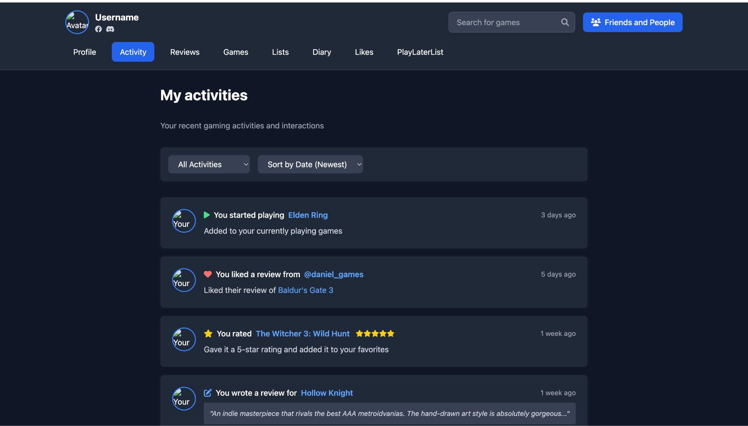

**Description**

**Purpose: This screen is to display all activities of users.**

**Design:**

**Activity Feed**

* User actions listed with timestamps, such as:
  + “You started playing Elden Ring 3 days ago”
  + “You liked a review from Daniel”
* Includes avatar of acting user (shown on the left of the activity)

**Can be sorted by date**

# **Interface of Lists**

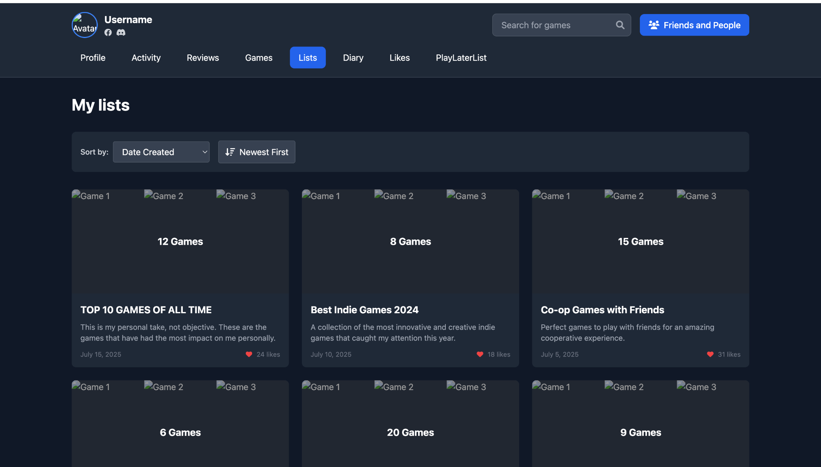

**Description**

**Purpose:** This screen is to display all the lists made by users

**Design:**

**List Overview**

* Each list includes:
  + Cover/posters of first few games the user adds to that list
  + List title (e.g. "Top 10 Games of All Time")
  + List description
  + Date created

**Can be sorted by date**

# **Interface of a game**

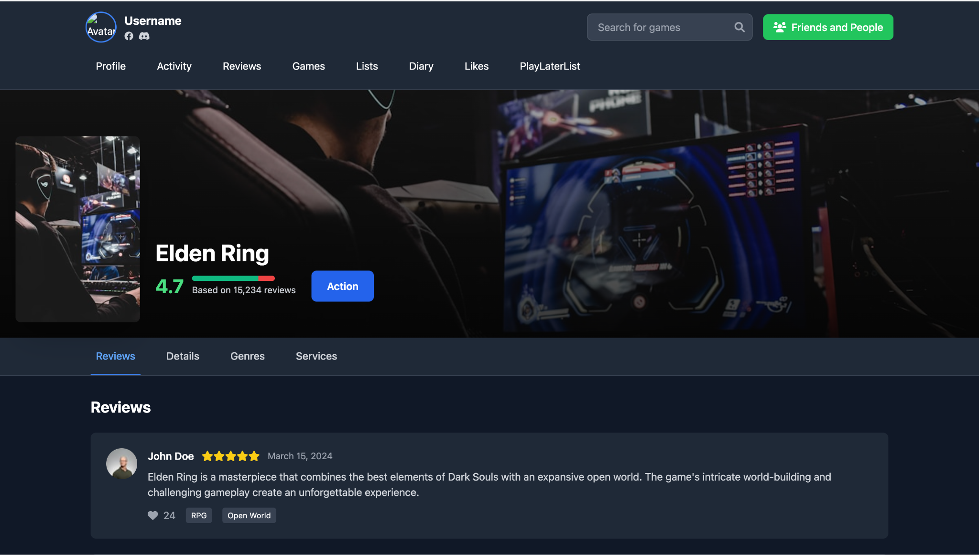

**Description**

**Purpose:** This screen is to display a game’s rating and interactions

**Design:**

**Game Card Features:**

* **Poster**
* **Backdrop (a picture from the game)**
* **Rating Score** (e.g., 4.7) with a rating curve graph (like Letterboxd)
* **Action Button** (including log, like, review, add to list)
* **Tabs**:
  + Reviews (by others)
  + Details (studio, country, languages)
  + Genres
  + Platforms/Services (e.g., Steam, Nintendo Switch)

**Note: The action will be a pop-up showing all the actions you could do with a game on this platform.**

# **Interface of a game review**

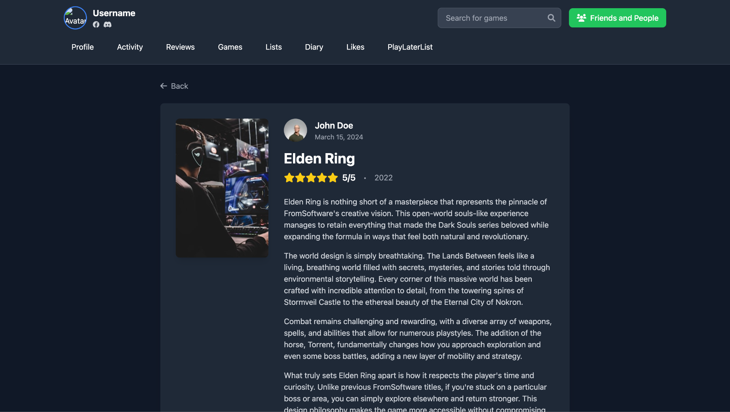

**Description**

**Purpose:** This screen is to display a game review

**Design:**

Each review includes:

* Poster
* Avatar and username
* Game Title
* Rating
* Publication Year
* Review Text
* Reaction Count
* The tags (added by users)
* **Comment section:** includes a list of comments (with avatars and reactions)

Note that interface 10 and 11 will serve as the windows users get transferred to whenever they click on a game (from search, from a list made by a friend, from their diaries). If there’s a review (written by you or your friends) you will get transferred to the game review window first, clicking on the poster in the game review window will bring you to the game detail window.

The search engine will allow user to search up games’ names and lists made by other users.

# **Interface of Friends and people**

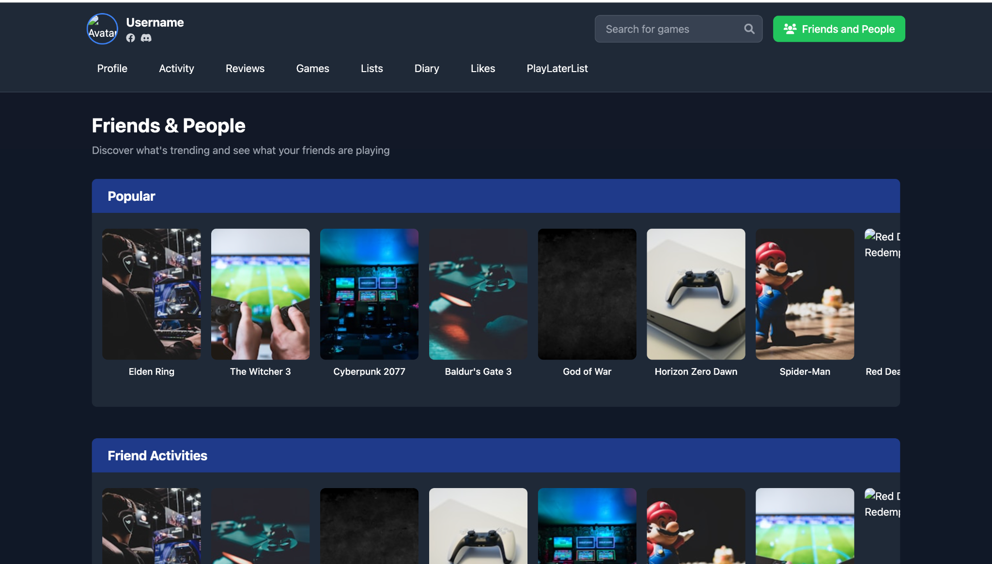

**Description**

**Purpose:** This screen displays curated content from across the community and from the user’s friend network.

**Design:**

The interface is divided into **three horizontal sections**, each headed with a bold title on a dark blue background. Each section shows a scrollable row of **game posters (thumbnails)** with labels underneath:

* **Popular**: Trending games among all users.
* **Friend Activities**: Recently rated or reviewed games from the user’s friends.
* **Popular with Friends**: Games that are widely liked by the user's friend group.

# **Interface of search engine**

**Description**

**Purpose:** This screen displays the results when users put in a name of a game or a member

**Design:**

The design of this screen includes

* A search bar in the top right allowing users to put in what they want to search
* Two features including games and members to choose from
* A list of games or members that match the input of users, displaying the posters and information of each game (names, years published).